**Algorithm 3: Multi-targets tracking**

1. While all targets not found yet or # of cycles < N

2. Calculate new UAV way poins sets (actions)

3. For each target in target pool

4. If target detected but not found yet

5. Estimate target location through **Boostrap Filter**

6. Else

7. Propagate estimated location through state-space model

8. End

9. Calculate next UAV way point throuhg **Control Vector Selection**

10. If found condition meet

11. Add target location & found cycle into found target list

12. End

13. End

14. Compare observation data for all not found targets to update next UAV way point

15. End

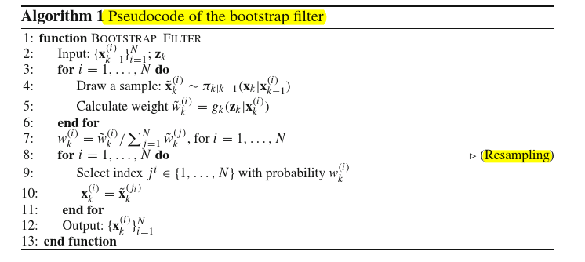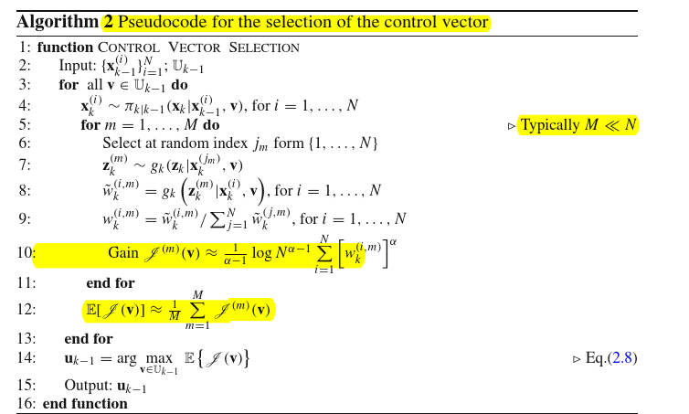

References: Branko Ristic, Particle Filters for Random Set Models, 2013, Springer.